**Website Audit for bahamas.com**

Search Engine Optimization, or SEO, is essential to the marketing success of modern businesses. We help companies develop SEO strategies that attract organic website traffic and generate high-quality leads. This SEO audit has been specifically prepared for **bahamas.com.**

1. **Traffic Analysis:**

We have done an analysis of the website and found that there is a slight improvement in website traffic as compared to 2020. There are lots of SEO opportunities to increase website traffic.

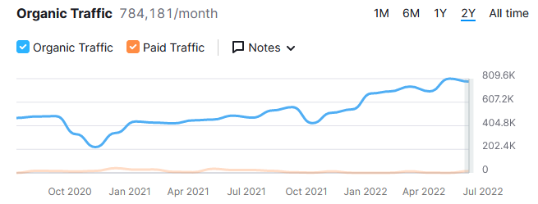

**Note:** This i information from an SEMRush tool. We will do a more detailed analysis after getting access to Google nalytics from you.

**Our Proposed Solution:**

Our suggestion is to improve organic traffic for **bahamas.com**:

1. Improve ranking for our target keywords in SERP (Search Engine Results Page) with On-page and Off-page optimization
2. Optimize your website content - "Content is king"
3. Regular blog posting
4. Search console analysis (query and page analysis)
5. Examine analytics data
6. Secure more referral traffic
7. Make sure your site is (optimized/loads fast?) fast
8. (Namrata to share suggestions; probe for other relevant competitive analyses we can set up in a “dashboard”) and out-maneuverer them on SEO (ethically and responsibly, of course)
9. Create content that appeals to influencers and referral sources
10. Improve the firm’s (firm?/government or agency responsible for website, no?) organic click-through rate

**B) Keywords Analysis:**

I have checked the current status of keywords and found that most of the main keywords are not ranking at the top position.

|  |  |
| --- | --- |
| **Keywords** | **Search Volume** |
| islands in bahamas | 100000 |
| bahamas resorts | 100000 |
| exuma bahamas | 100000 |
| bimini bahamas | 100000 |
| paradise island bahamas | 100000 |
| warwick paradise island bahamas | 100000 |
| long island bahamas | 10000 |
| exuma bahamas resorts | 10000 |
| bimini bahamas resorts | 10000 |
| paradise island bahamas resorts | 10000 |
| long island bahamas resorts | 1000 |
| islands for vacation | 10000 |
| islands vacation | 10000 |
| best island vacations | 10000 |
| best places in bahamas to stay | 10000 |
| best vacation spots in bahamas | 10000 |
| bahamas islands resorts | 1000 |
| vacation spots in bahamas | 1000 |
| best places to vacation in the bahamas | 1000 |

**C) Competitor Analysis**: we have done a Competitor Website Analysis. In the following tables, you can see that **sandals.com**, **myoutislands.com,** and **holidify.com** have 7,561,383, 184,075, and 1,166,515 backlinks from 8,949, 11,821, and 7,971 domains while **bahamas.com** has 1,722,343 backlinks from 8,949 referring domains. Here are our top three competitors:

|  |  |  |  |
| --- | --- | --- | --- |
| **We** | **Backlinks** | **Ref. Domain** | **Indexing** |
| bahamas.com | 1722343 | 8949 | 4210 |
| **Competitors** | **Backlinks** | **Ref. Domain** | **Indexing** |
| sandals.com | 7561383 | 11356 | 7960 |
| myoutislands.com | 184075 | 1273 | 823 |
| holidify.com | 1166515 | 7971 | 80300 |

Following is the detailed list of competitors for “**bahamas.com**” in Bahamas:

[https://docs.google.com/spreadsheets/d/1lWaB78sU09eN4pmS9vymCDWyWS0w6wtweaAoJlDhr4E/edit#gid=0](https://twitter.com/visitthebahamas#gid=0)

**D) General Analysis:**

In this section, we have listed some of the most important SEO factors that are important for website rankings.

|  |  |  |
| --- | --- | --- |
| **Elements Analyzed** | **Findings** | **Why this Matters** |
| Web Address Age: | Your website is good on this factor as the age is 24 Years 20 Days | Search Engine Algorithms measure a variety of parameters. Domain age is a big one that improves the overall score. |
| PA & DA | Currently Status is DA 68 & PA 61 | Page Authority measures the predictive ranking strength of a single page; Domain Authority measures the strength of entire domains or subdomains. After Google Rank off, measured by PA & DA. (Given by MOZ) |
| Number of Indexed Pages on your site | 4210 pages are indexed in Google | When Google indexes a page, it tells us that Google knows it exists. The entire Website is indexed in Google. |
| Backlinks (Number of External sites linked to your site) | 1722343 backlinks from 8949 unique domains | Backlinks are one of the primary areas of emphasis and score improvement for us. Search Engines index a site’s pages every time a link is made from another site. |
| Does this site have an XML site map? | XML Sitemap Exists | An XML site map is a search engine-friendly map that is coded specifically to help search engines quickly find and retrieve the information from your site. This file plays a vital role in the optimization process. |
| Meta Tag and Title Analysis | Titles exist but **we can optimize them** | Meta tags are in the form of a description and keywords tag. Meta descriptions are present on most of the pages, but we need to optimize them. |
| Image Tag (Alt Tag) Analysis | Yes, but not optimized | Search Engines can only see and retrieve text. Images become wasted space on a page. To make the best use of the image areas, SEO experts will place important keywords in these image tags so the engine can use them**.** |
| Does a Robot File Exist | Found | This file is important because it is your website way of giving instructions to search engines about how to index your website. |
| Does This Site Use Search-Engine Friendly Footers? | Yes | The footer hyperlinks that you sometimes see at the bottom of a web page are done in a keyword-focused way and can be very powerful in the search engine optimization process. It allows another opportunity for content to index and improves your rankings. |
| Keyword Density | **More opportunity to add keywords** | This is the whole reason search engines even care about your site. It is critical that pages have a nice balance of keywords that we identify are best from our research. |
| Website Home Text Content | **Opportunities to add more content** | The search engines can only index text content and cannot see the flash. |
| Structured Data | Yes | Schema code is important for local SEO ranking. It helps Google to understand correct business information. |
| Are Page URLs Named Effectively? | Yes | The URL is where a search engine starts its journey. Each page of a site has a URL. By adding a keyword to the name, gives the search engine more to work with. |

**E) Website Speed:**

Website speed is one of the important factors for website ranking. In our page speed analysis we have found that your website speed is not good on desktop and mobile devices as compared to your competitors. Website Speed Data is according to **Google Pagespeed Insights Tool.**

[https://pagespeed.web.dev/report?url=https%3A%2F%2Fwww.bahamas.com%2F](https://twitter.com/sandalsresorts?url=https%3A%2F%2Fwww.bahamas.com%2F)

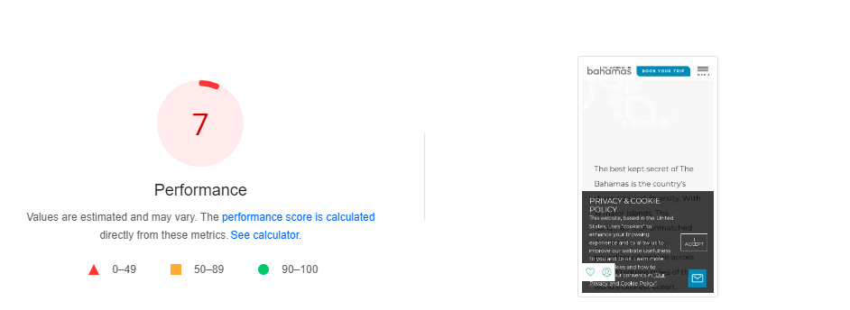

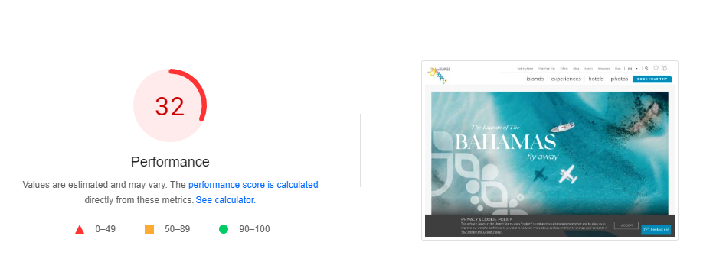

**F) On-Page SEO analysis:**

After analyzing the complete website, we found that there are many opportunities for optimizing the website in terms of different on-page factors:

**1. Title:** During the analysis, we found that meta titles are not optimized on any page. We need to optimize the title on all web pages with proper primary and secondary keywords which should contain 60-65 characters title length.

**Example:**

**Page URL:**

[https://www.bahamas.com/islands](https://docs.google.com/spreadsheets/d/1lWaB78sU09eN4pmS9vymCDWyWS0w6wtweaAoJlDhr4E/edit)

**Current Title:**

The Bahamas Islands - Discover 16 Unique Island Destinations

**Suggested Title:**

The Islands of Bahamas - Discover 16 Unique Island Vacation Destinations

**2. Duplicate Meta Title Issue:**

During our website analysis, we found some pages with duplicate title tags. Duplicate title tags can make it more complicated to rank content in search results because search engine crawlers won't know which post to rank above the other. If you want to rank your pages without confusion or without having them compete with one another, creating unique and relevant title tags is incredibly important. Here is the screenshot:

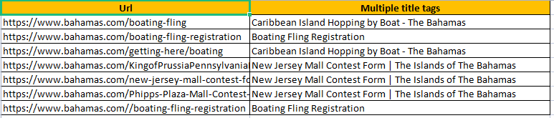

**3. Duplicate Meta Description Issue**:

During our website analysis, we found some pages with duplicate meta descriptions. Having duplicate meta descriptions can make the ranking process more difficult as engine crawlers will have a hard time figuring out the differences between pages and what should rank and what shouldn't. Here is the screenshot:

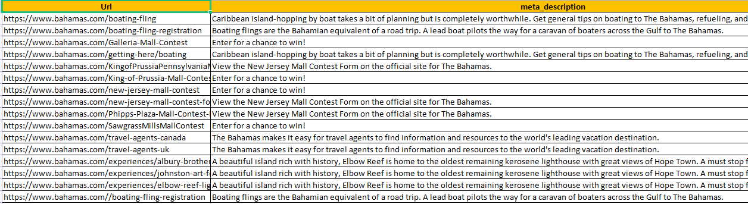

**4**. **Missing H1 Issue**:

During our website analysis, we found some pages with missing H1 headings. Search engine crawlers prefer content that is structured properly and has a hierarchy when it comes to heading tags. The H1 tag is the most important and tells search engines what it is your content is about. There should only be one H1 tag for each page. Here is the screenshot:

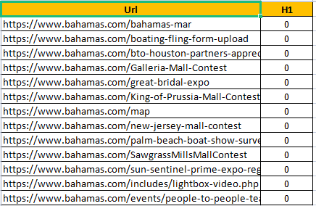

**5. Missing Meta Title**:

During our Website Analysis, we found a page with a missing meta title. Title tags appear in search results and let people know what the name of the article or page is that they are considering opening. If you don't add a title tag to your page, it will be much more difficult to rank. Here is the screenshot:



**6. Missing Meta Description:**

During our website analysis, I have found some pages having missing meta descriptions. Meta descriptions can significantly increase the chance of someone clicking on your content in the search results. The meta description lets people know what to expect on the page they are about to open. If you choose not to add an optimized and intriguing meta description, the search engine will typically add the first sentence of the page. Here is the screenshot:

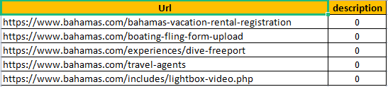

**8. Permanent Redirection (301) Issue:**

During our Website Analysis, we found some page URLs which are 301 redirected. We need to resolve this issue. Here is the screenshot:

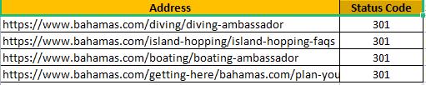

**9. Multiple H1 Issue:**

During Website Analysis, I have found some page URLs having multiple H1 headings. We need to use only one H1 for each website page. Here is the screenshot:



**10. Duplicate H1 Issue**:

During our Website Analysis, we have found some page URLs having duplicate H1 heading. Here is the screenshot:



**11. Sitemap Issue:**

During website analysis, I have found a sitemap for the website but it is not showing properly. We need to resolve this issue by using an SEO plugin. The screenshot is given below:

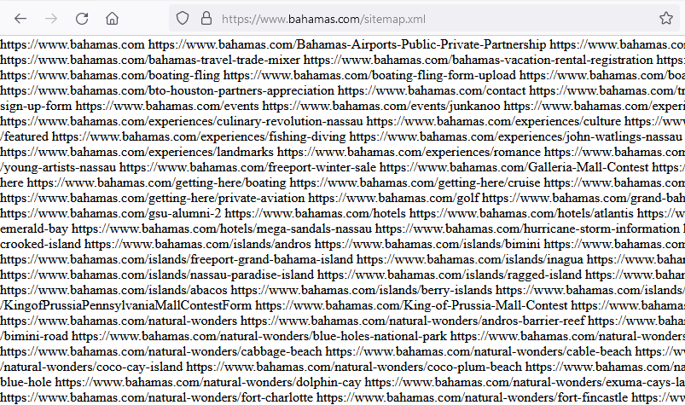

**G) Broken Links:**

During our website analysis, we found some broken links on the Website. Broken links affect the SEO of a website because it affects user experience which is a ranking factor. These links could be quite annoying and result in a poor user experience. Here is the screenshot:

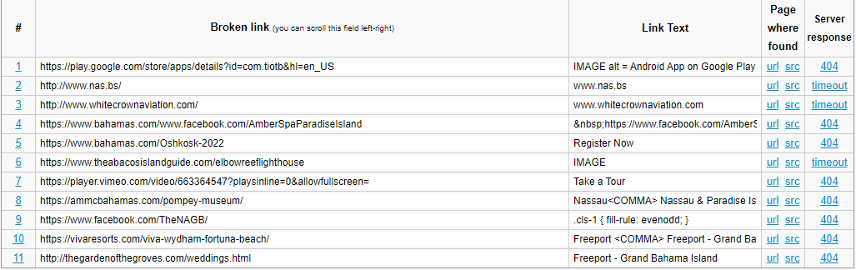

**H) Backlink Analysis:**

Backlinks are important for any website’s ranking. Good and high-quality backlinks help to improve keyword ranking. We have seen that **bahamas.com** has a good amount of backlinks, we are getting 1722343 backlinks from 8949 referring domains. Here is the screenshot:

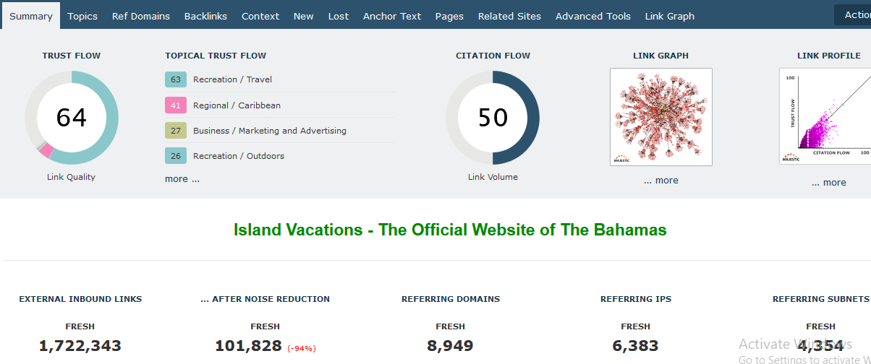

**I)** **Blog Audit**:

During our Website Blog Analysis, we noticed that competitor(s?) is writing more tourism-specific blog post topics to attract visitors and gain traffic. They have also categorized blogs in the following sections:

* Destinations
* Activities and Attractions
* Food and Drink
* Behind the Scenes & more
* Wedding Destinations

**Competitor Blog Page URL**:

<https://www.sandals.com/blog/>

**Here is the Screenshot**:

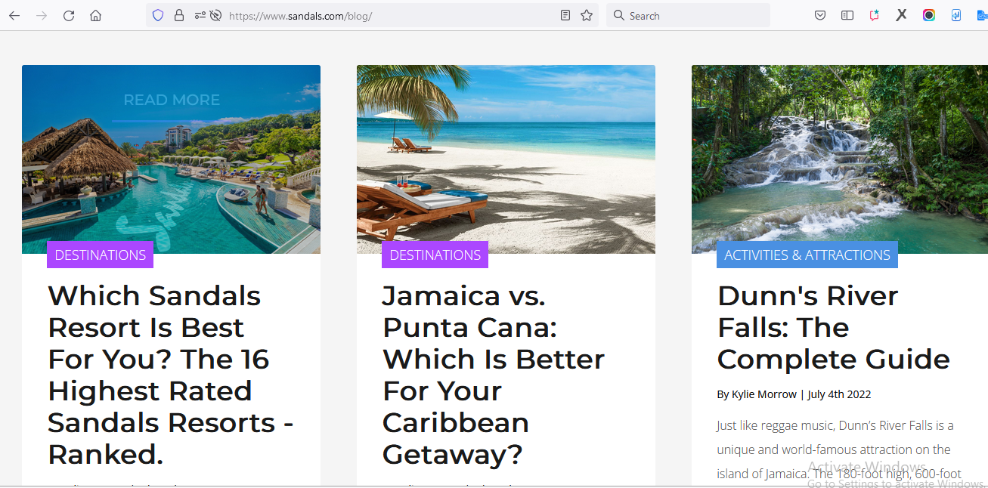

We have also noticed that the competitor is posting 3 to 4 blogs on a monthly basis, but we have not posted any content after 10th June 2022. Also, We do not have any content posted in the other “**Search By Island**” categories. It is suggested to post blog content 8 - 10 times monthly to drive more traffic. Below is the screenshot of the last posted content:

**Our Blog Page URL:** [**https://www.bahamas.com/blog**](https://www.bahamas.com/blog)

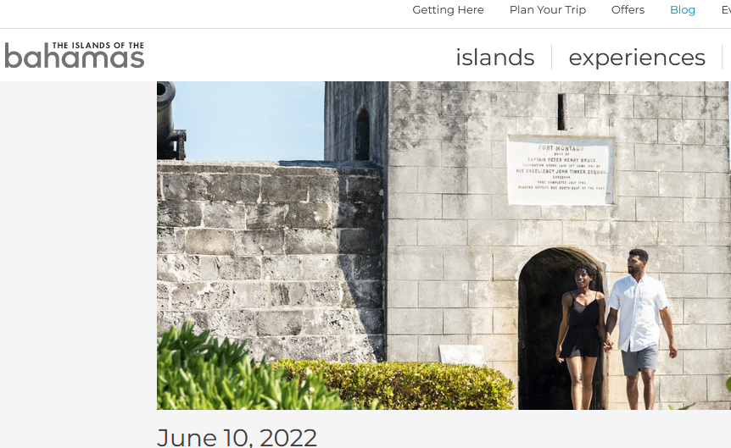

**J) Social Media Audit:**

During Website Social Media Analysis, we noticed that we do not have social media links placed in the header section of the icon, but our competitors have those links in the header section. We recommend adding social media links in the header section also for better social media engagement. Here are the screenshots:

**Competitor Website:**

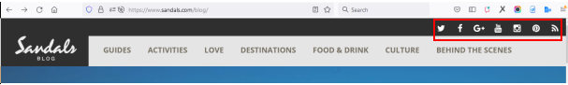

**Our Website:**

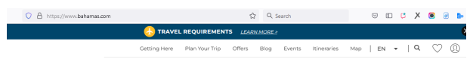

**1) Instagram Page**:

During Instagram Page Analysis, we found that we have less followers than our competitors. We need to post attractive content to gain traffic on Instagram. Here is the screenshot:

**Competitor Instagram Page:**

[https://www.instagram.com/sandalsresorts/](https://pagespeed.web.dev/report)

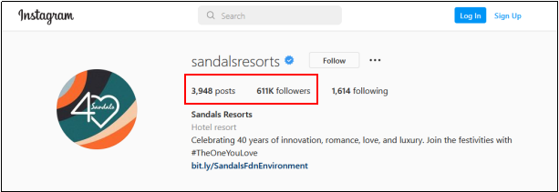

**Our Instagram Page:**

<https://www.instagram.com/VisitTheBahamas/>

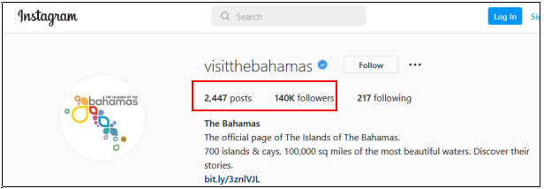

**We need to use the homepage URL on Instagram instead of the service page:**

**Current URL:**

<https://www.bahamas.com/experiences/bimini-dolphin-house>

**Suggested URL:**

[https://www.bahamas.com/](https://www.instagram.com/sandalsresorts/)

**Here is the screenshot:**

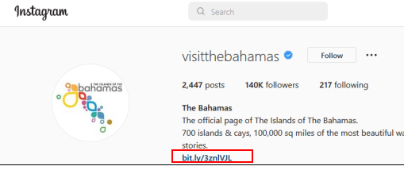

**2) Facebook Page**:

During Facebook Page Analysis, we found that we are using (what?) without using https:// website on the page. We need to use the correct website URL, likes and follow icons, and small about us descriptions on the Facebook homepage to gain more visitors. Here is the screenshot:

**Competitor Facebook Page:**

<https://www.instagram.com/sandalsresorts/>

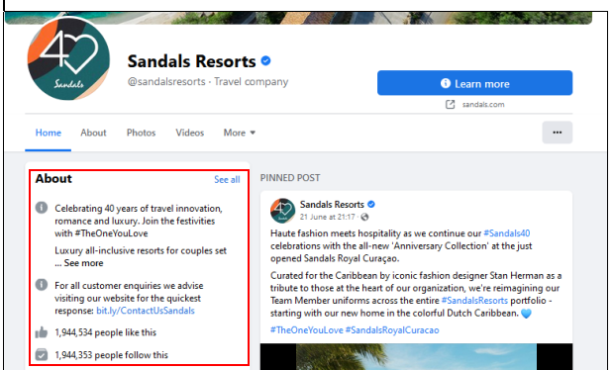

**Our Facebook Page:** <https://www.facebook.com/TravelBahamas>

**Homepage URL is used without HTTPS**

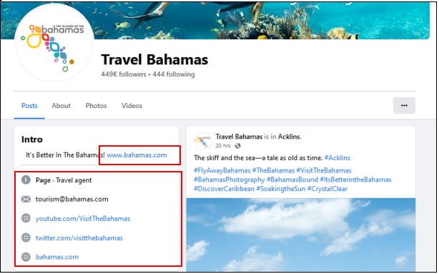

**3) Twitter Page**:

During Twitter Page Analysis, we found that we have less followers than our competitors. We need to tweet our latest updates on tourism to gain more followers. Here is the screenshot:

**Competitor Twitter Page:**

[https://twitter.com/sandalsresorts](https://www.bahamas.com/islands)

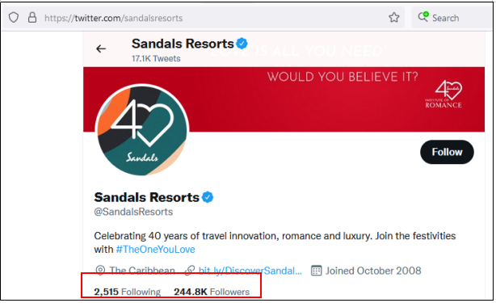

**Our Twitter Page:**

[https://twitter.com/visitthebahamas](https://www.bahamas.com/)

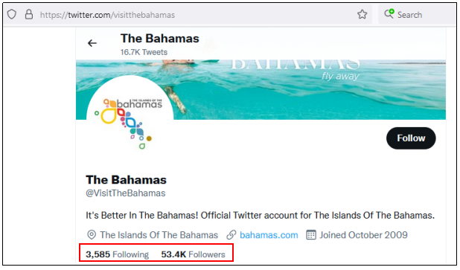

**3) YouTube**:

During YouTube Analysis, we found that we have less followers than our competitors. We need to post the latest videos on island destinations to gain more subscribers. Here is the screenshot:

**Competitor YouTube Page:**

<https://www.youtube.com/user/SandalsResorts>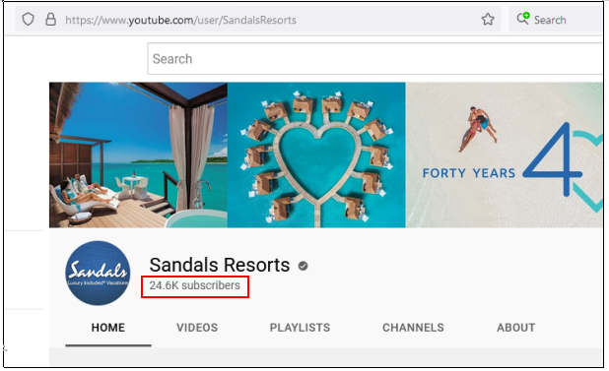

**Our YouTube Page:**

<https://www.youtube.com/user/VisitTheBahamas>

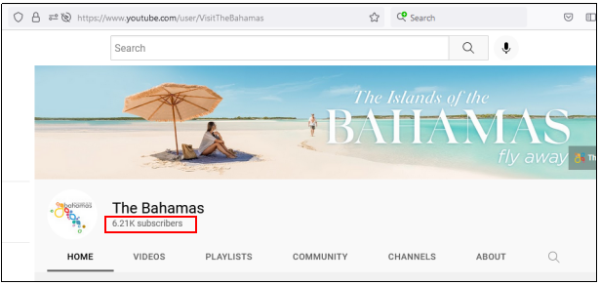

**K) W3C Validation:**

During our Website Analysis, we checked and found that our website is not W3C validated. Here is the screenshot:

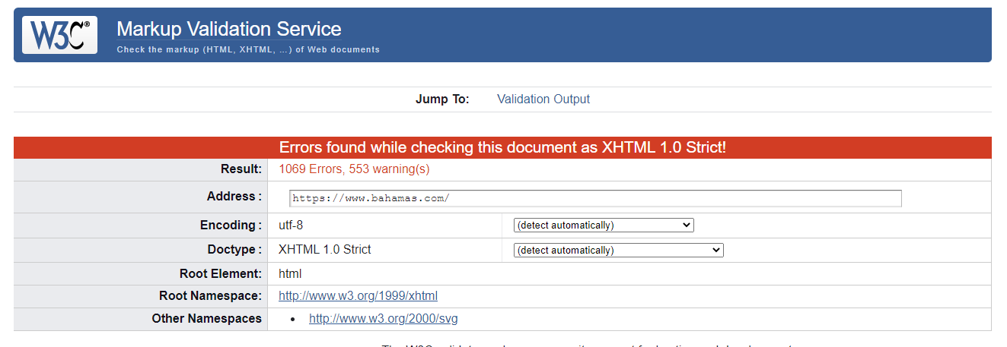

**L) Citation Analysis:**

We completed a citation analysis for **bahamas.com** and found that our business is not listed on important business listing sites. A screenshot is shown below:

